Lighting and Particle Systems in Unity

Table of Contents

Introduction 2

Lighting in Unity 2D 3

Setup 3

Light2D component 3

Post Processing Bloom 4

Lighting examples from the Industry 7

Application of Lighting in my own Game 8

Particles in Unity 9

Particle System Component 9

Particle system examples from the Industry 10

Application of Particle Systems in my own Game 12

Final Thoughts 12

# Introduction

Visual polishing is always an important factor when it comes to the development of video games. It can help make the difference in having a game that feels alive and joyful instead of dull and boring. Even if a game has great mechanics, an interesting story, or even stunning visuals – lacking the correct amount of polishing can easily result in a sub-par atmosphere. On the other hand, great polishing is often enough to hide otherwise lackluster visuals. Another, on the first hand often overlooked usage of visual polishing can be of a rather functional nature. In addition to being visually beautiful, it can be utilized to guide the player’s eye or communicate important gameplay information.

In order to gain a better understanding of the topic, I conducted some research on two of the arguably most essential ways of visual polishing: lighting and particles, and how to apply them in Unity 2D.

In this article, I will analyze and discuss the outcomes of that research, combined with examples of best practices from the industry. I will also show how I applied that knowledge in one of my own games and how I went from this…



… to this:



# Lighting in Unity 2D

## Setup

When creating lighting for a 2D game in Unity, the *Universal Render Pipeline* (URP) in combination with the *2D Renderer* is the way to go. (Unity, 2023). It offers a *Light2D* component that is optimized for lighting 2D sprites. The URP needs to be installed via the Unity package manager. Also, to set up the project to use the URP, a *Pipeline Asset* must be created and dragged into the *Scriptable Render Pipeline Settings* slot under the graphics tab in Unity’s project settings.

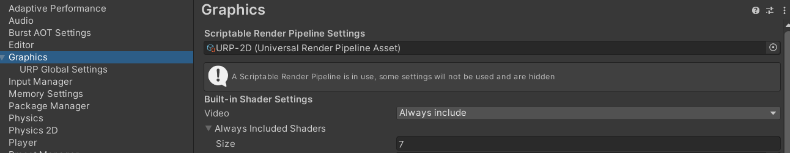

Next, to configure the project to 2D, a *URP 2D Renderer* must be created and added to the *Renderer List* of the Pipeline Asset.

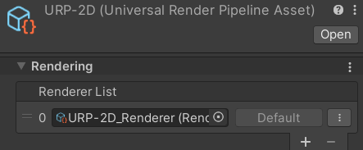

Now Unity will only render 2D lights. One more important thing is that sprites will only be affected by lights if they have a material that is configured to do so. Unity’s standard material for that is *Sprite-Lit-default*.

## Light2D component

Now that the project is set up correctly and all sprites that we want to be affected by light have the correct material selected, all we need to do is actually create some light components because the scene will be completely black at the moment. The Light2D component is available in four different types:

* *Global* = Uniformly shines light onto all objects
* *Spot* = A single point of light
* *Freeform* = An area of light with a freely editable shape
* *Sprite* = A form of freeform light that has the shape of a selected sprite

All of these lights have a few attributes in common. *Intensity* controls how bright a light is. *Targeting Layer* is used to determine what objects will be affected by the light. *Color* – you guessed it – controls the color of the light. Additionally, spot- and freeform lights also have values to set the range of the light, like *Radius* or *Falloff Strength.* (Brackeys, 2019) (Unity, 2023).

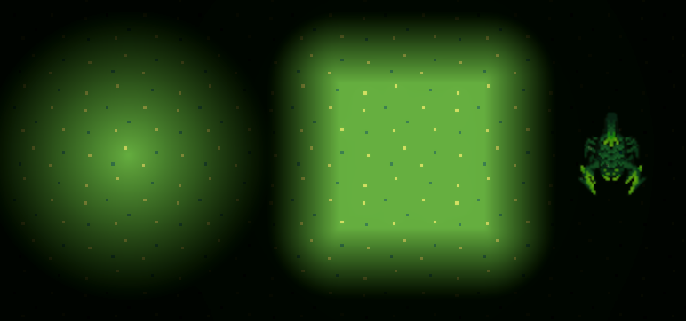

Apart from these standard settings, there are also some more advanced options. The light can be enabled to affect *Normal Maps* to better represent a texture’s height profile and create the illusion that it is not just a flat 2D surface.

*Shadows* can be enabled, for objects to cast shadows when the light source shines on them. For this to work, a *ShadowCaster2D* component needs to be added to all sprites that should be affected by the light. Here, the shape of the shadow caster can be edited, to represent the sprite it affects.

*Volumetric* is a type of light that makes the light rays themselves visible. Examples of volumetric light are when light shines through fog or smoke, or when it shines through an open window into a dark room. It can create a certain aesthetic or be used to direct the eye of the viewer. (DeGuzman, 2022).

Lastly, *Blending* can determine if the light should be added on top of other sprites, or if the sprites and the light's color should be combined.

*Additive blending*: *Multiplicative blending:*

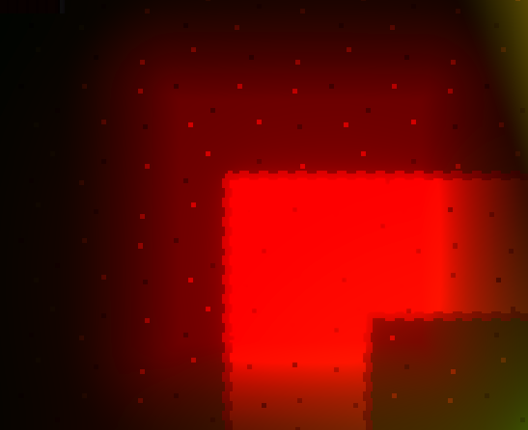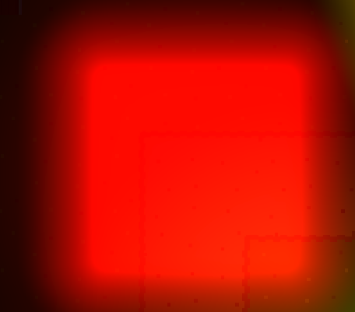

Of course, most of these options can also be edited via code. For example, a script could randomly increase and decrease the intensity of an orange light in an interval, giving the impression of a flickering flame. Or the intensity of the global light could be changed, to simulate a day-night-cycle.

## Post Processing Bloom

Another way to enhance the light atmosphere in a scene is an effect called *Bloom.* It works by taking the bright parts of an object and blurring them out, to create the effect as if the object is emitting light by creating fringes or feathers around the object. Bloom is imitating an artifact of real-world cameras – or the human eye – where the sensor is overwhelmed by an overly bright light. (Brackeys, 2020) (Unity, 2017).

A Scene with bloom: A scene without bloom:

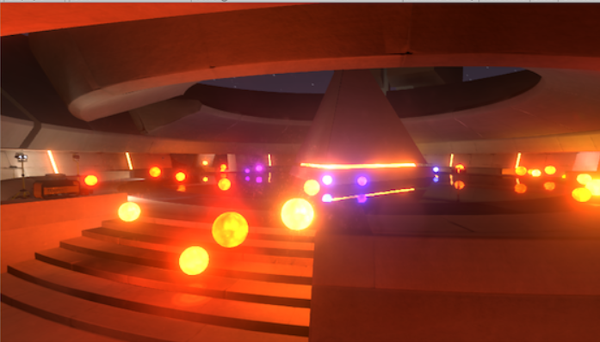 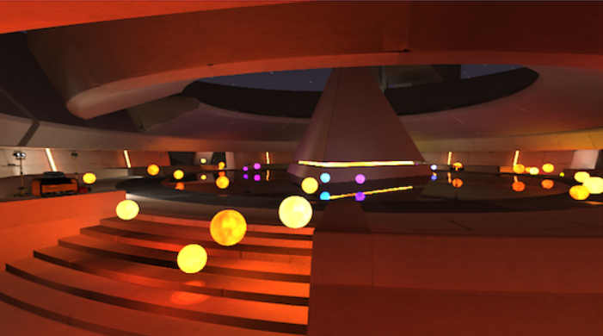

Like the Light2D component, the post-processing effect of bloom also relies on the URP. To set it up, a *Volume* object must be added to the scene together with bloom as a *Post Processing Effect*.

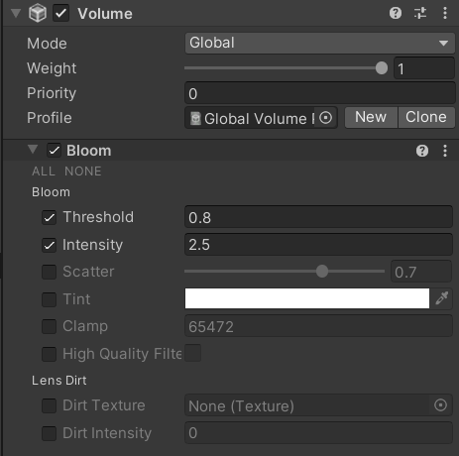

Furthermore, the field *Post Processing* must be enabled on the main camera and *HDR* on the pipeline asset under *Quality*.

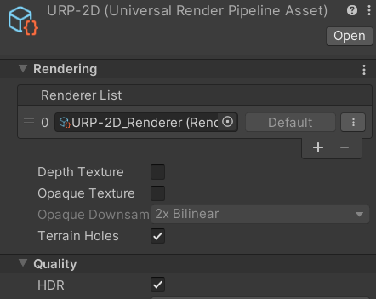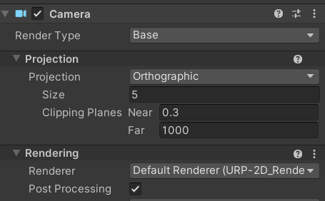

Now that the bloom effect is correctly set up, we can start adding it to the scene. In the added bloom component, many different settings are presented, but the main two are *Threshold* and *Intensity.* Intensity sets the strength of the effect, while threshold determines which areas should be affected. It defines how bright something should be, in order to be affected by the bloom effect. (Brackeys, 2020).

This way, bloom is added to all lights in a scene, but there is also a way of making it work with sprites. Not only do the lights get the effect, but also certain areas of the sprites themselves, resulting in an amazing look, and the best part is that this even works with animations.

To set this feature up, the animation spritesheet needs a so-called *emission map* set as a secondary texture. An emission map is basically just a version of the spritesheet with a black background and all of the pixels painted white, that should be affected by the bloom. The intensity of the white can also be changed, to alter the intensity of the effect in the end. E.g.: a grey tone will not shine as brightly as a more intense white.





Once the emission map is set up, we need to write a simple shader graph that actually uses it. For this, two input textures are needed for each of the two images. They need to be combined via an *Add Node* that combines the RGB value of the spritesheet with either the R, G, or B value of the input map. This already results in a white bloom effect on the animation. To change the color of the effect, we can add a *Color Node* to the shader graph and multiply the emission map with it. Now we only need to create a material with the shader graph, add it to the gameobject, set the color in the inspector – or via code – and see the effect in the scene. (Brackeys, 2020).

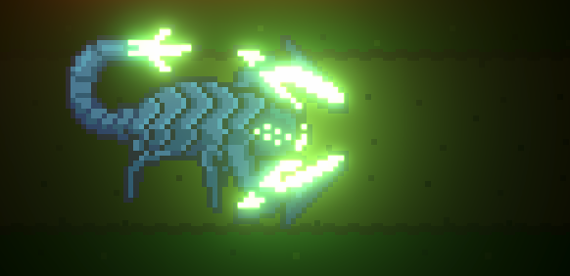

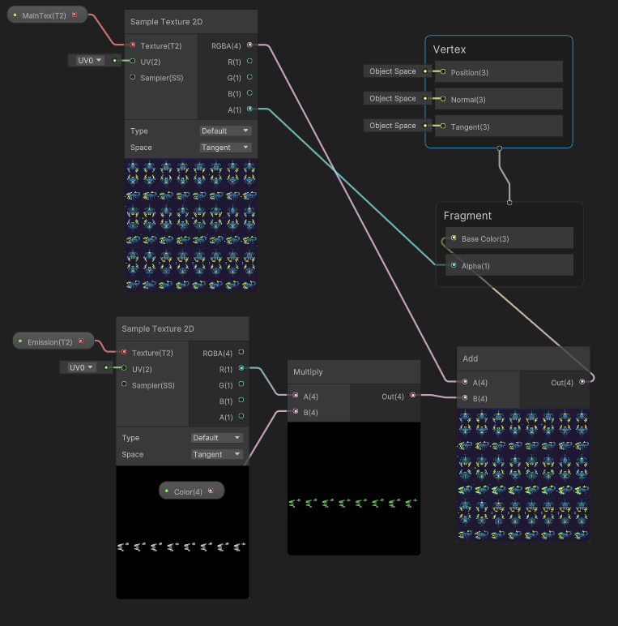

## Lighting examples from the Industry

The first and most important job of lighting in any form of media is of course for the viewer to see what’s happening. Secondly, different ways of lighting a scene can result in many different atmospheres and therefore trigger different emotions in the viewer. Apart from these two main aspects of lighting, video games also use lighting for specific gameplay purposes. (Houze, 2019).

In *Uncharted 4: A Thief’s End* lights are placed at certain points to catch the player's attention, acting as guiding elements in a level. This is a design approach seen in many games. (Houze, 2019).

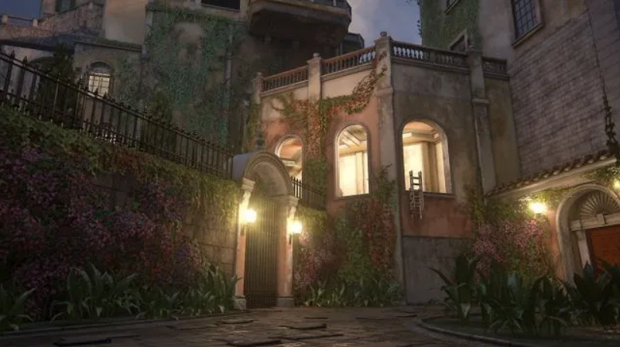

Some games like *Dark Souls 1* in the *Tomb of the Giants* section use light and darkness as essential mechanics for the area. It is so dark that the player needs to equip a special lantern item in order to see anything at all. Even with that lantern the range of vision remains small, making the limited available light an obstacle of its own.

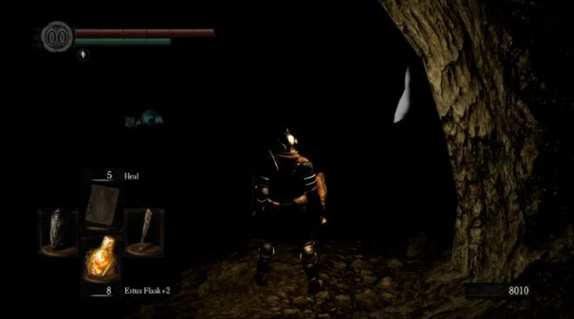

Lastly, another application of lighting in a scene can just be to signal something to the player, acting as feedback. This happens in *Deus Ex: Mankind Divided* where the light cone of a security camera changes its color to yellow when it sees an enemy and red when the enemy does not leave the field of view for a few seconds.

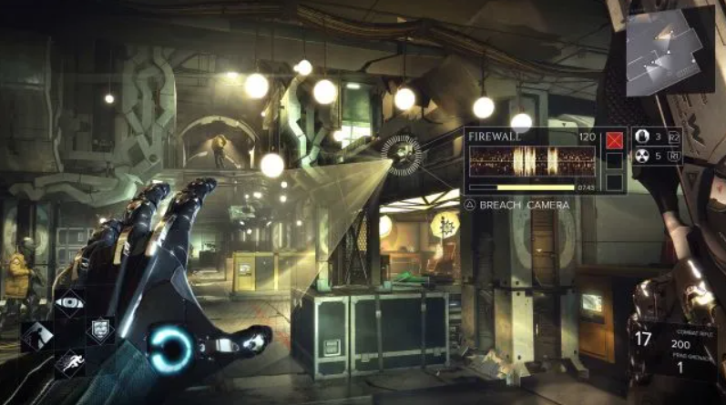

## Application of Lighting in my own Game

When designing the lighting for my tower defense game, I first made the big decision to make use of a day-night-cycle. I implemented this by having the global light turned down during the attack phase of the enemies, and then having it returned to daytime during the building phase in between waves. This has a few different effects on the game. Firstly, it drastically changes the atmosphere from being rather friendly to almost scary at night time. Secondly, it hides the low quality of the free third-party assets I used for the game. Thirdly, it requires additional lighting on all objects the player should be able to see during the night, drawing the player's attention to the important elements on the screen. Finally, it makes much more sense from a story perspective that the monsters only attack at night. A problem I encountered by choosing this approach was that I needed to keep track of all lights that are in the scene, to be able to tone them down during daytime which would otherwise result in a strange look.



One interesting application of light sources in my scene is the addition of spotlights to the towers. Since the towers turn towards the enemy, a spotlight on the tower that always faces the direction the tower is shooting acts as a guiding line for the player that illuminates the action. Additionally, all towers, projectiles, enemies, and effects have their own specific light source, with different properties, making it easy for the player to distinguish between them, even during the low-light phases of the game.

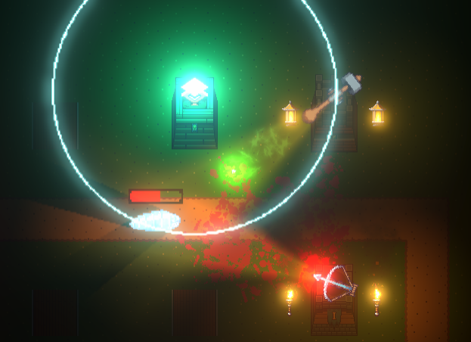

# Particles in Unity

## Particle System Component

Particles in Unity are handled by a single component called *Particle System*. It can be set up to emit particles in many different ways, but since there are so many different properties to set, I will only give an overview of the most important ones.

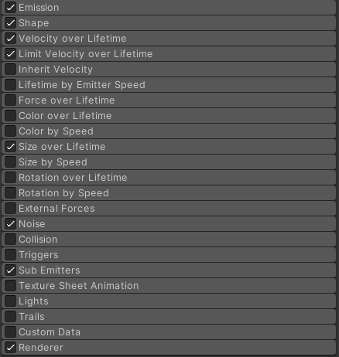

First of all, the emitter needs a material that holds the texture that the particles should have. The system will emit particles over a set duration, except when looping is enabled, which will spawn particles indefinitely. Particles will spawn with a set size, speed, rotation, and color – all of which can be set up to change during the particle's lifetime. Whenever one of those values is set up, the component offers the option to either set it to a single constant, a random value between two constants, a curve, or a random value between two curves. This way a particle system can easily be randomized, so it acts differently for every particle.

The shape of the emitter can be set to several different options. A circular emitter would emit particles in any direction, while an edge-shaped emitter only in one. Emissions can happen in bursts of many particles in a certain interval, at a constant rate over time, or travelled distance of the emitter. The last option comes in handy to create dust particles at the player's feet when walking for instance.

Particles can be set up to collide with different objects, follow gravity, emit light, or respond to custom triggers.

A *Trails* option can be enabled, which requires a second texture to be rendered as a trail behind particles. A *Noise* option can be set to even further randomize the position, rotation, and scale of particles, mimicking the effect of wind on smoke or waves on floating leaves for instance.

Lastly, the option S*ub Emitters* complicates the process even more. This enables every particle to spawn a whole new particle system with multiple particles of its own. The sub systems can be set to spawn on a particle's death, birth, a collision, or any other trigger. Certain values of the particle that spawns the sub system, can be passed onto it in a process called *inheritance.* Inherited values can be position, size, rotation, lifetime, duration, or any combination of those.

All of these options together with the ability to randomize make this component a powerful tool that can create an almost infinite amount of particle effects.

## Particle system examples from the Industry

A popular example of the right usage of particle effects is found in *Hollow Knight*. Fittingly, the game is made with the Unity Game Engine, showcasing its particle system at its highest capabilities. Generally, the usage of particle effects mostly comes down to two different usages: *visual enhancement* and communication of *gameplay information.* (NewFramePlus, 2020). Of course, effects always serve both purposes, but Hollow Knight manages to perfect its utilization of giving clear visual feedback to the player. A good example to show this in the game is the player characters hit animation. Since the game can be very hectic at times, with a lot going on the screen at once, the player might not be able to keep an eye on the player character at all times – in the worst case, leading to the player missing being hit. Hence the importance of communicating the information of being hit in a way that is really easy to notice, even in a confusing environment.

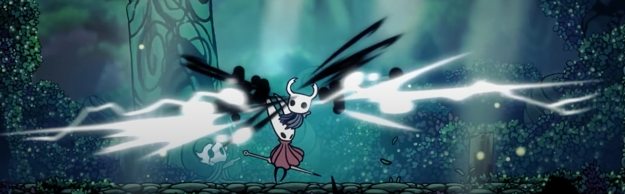



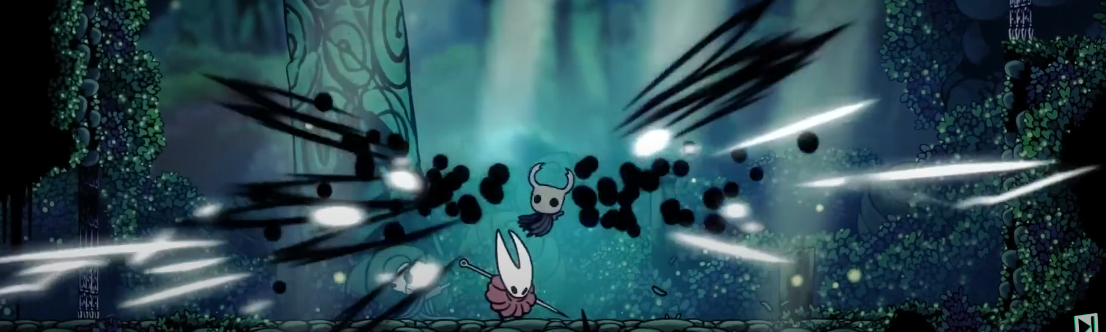

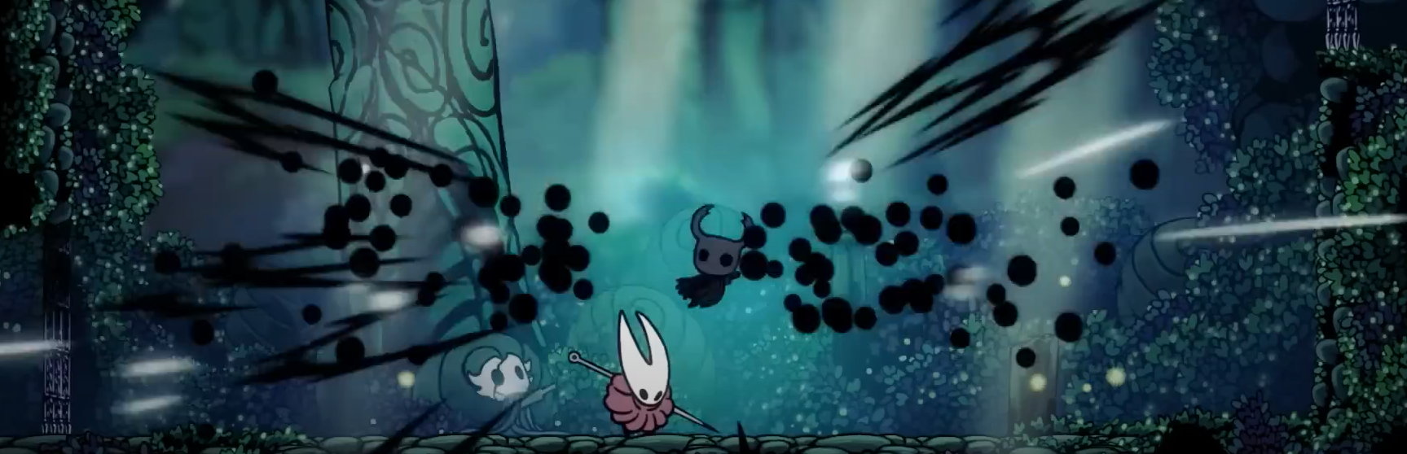

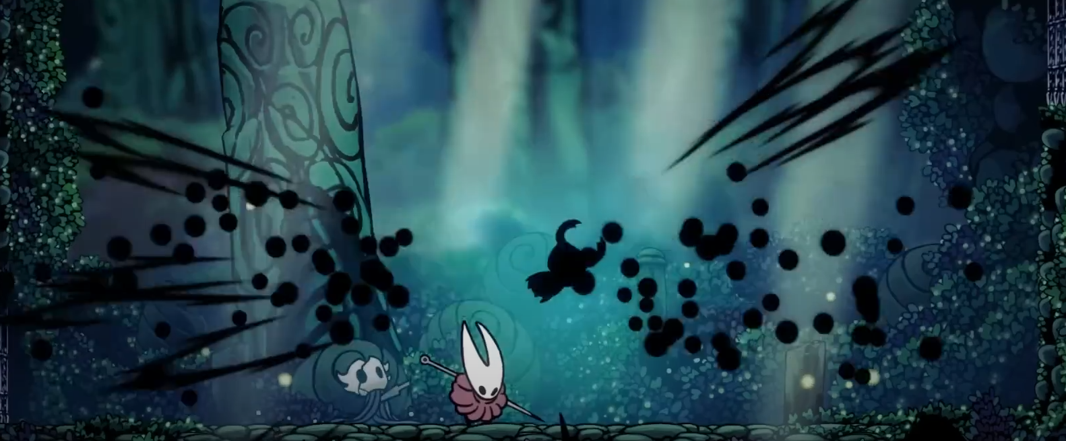

If we take a look at the sprite of the player character, we notice that there is a specific hit animation playing, but this would hardly be noticed, since the character is so small. To clearly communicate the hit and enhance the feeling of danger, the game uses Unity’s particle system to create giant black and white specks of energy, flying outwards from the player. This symbolizes the loss of life not only in a stunning way but also covers almost the entire width of the screen. Even if this only lasts for a few frames, it is an unmistakable, unmissable indication of the action happening. To further facilitate this effect, the game uses audio cues, screenshake, and freezes the player character’s movement for the time of the effect, but the most essential part of this effect is undoubtedly the particle effect.

Apart from Hollow Knight's clever utilization of particle effects as a communication tool, another implementation lies in the usage of particle effects for its visuals. (Dannycopo42, 2023). One of the most praised aspects of the game is its world and atmosphere. This of course is heavily contributed to by its gorgeous assets and animations, as well as interesting level design. Particle effects do play an important role in making the game’s world feel more alive though. Almost all environments have some form of dynamic effects that make them feel real and vibrant even if the player is not moving at the moment, like particles of ash blowing in the wind, drops of water falling from the ceiling, or water vapor rising from a pond:

 

In addition to this effect of creating a living and breathing environment even if the player does not move, the game also uses particle effects to create a reactiveness of the world when the player moves through it. In the *greenpath* region of the game, when the player character walks around, it kicks up leaves from the ground. Whereas in the *mushroom caves*, the mushrooms give up some spores when touched by the player character:



## Application of Particle Systems in my own Game

When applying those techniques to my own game, I tried to mimic them as well as possible. Of course, the difference in genres makes this very difficult, but I came up with some interesting ideas. I will not discuss all the effects that I added here because there are way too many but focus on a few important ones. The first particle effect I created, was a death animation for the enemies. Since my game is a tower defense game, there can be a lot of enemies on screen simultaneously. This can lead to quite some obstruction of vision, so it can be easy to miss an enemy dying. Similar to Hollow Knight’s hit effect, I added a particle effect that plays when an enemy dies, to communicate this essential game information to the player.



The effect was created by having multiple round sprites spawn from a circular emitter. They get assigned a radial velocity with randomized size and rotation values. When the particles reach the end of their lifetime, they spawn sub-emitters that can spawn a variety of different blood-splatter sprites on the ground, creating the illusion that the insides of the enemy were just spilled on the ground. These splatters on the ground stay for a short amount of time before they fade out, so the player can see the results of the fight at the end of each wave. Notice the difference between the effect for the big and small enemy. It is essentially the same effect, just scaled down. Also for the big enemy, there are two explosions, one with a short delay, creating a heightened effect of destruction.

Also visible are the particle effects on the torches that deliver a sense of action happening even if there is nothing else happening on screen in between the waves. Those were created by spawning randomized smoke sprites from a cone emitter, that slowly fade to transparency over their lifetime. Here I added some variable noise, that mimics the effect of wind on the smoke. A second particle system that spawns sparks gives the effect its finishing touch.

# Final Thoughts

Unity offers great tools that simplify working with both particle systems and lighting. With relatively low effort, it is possible to achieve results that disproportionately enhance the look and feel of a game, compared to the time it takes to set those systems up.

Unity’s approach is sometimes limiting though. You can only use these systems to achieve the effects that Unity had intended. For example, the option to set the shape of a light source to a sprite is very handy. Sadly, it is not possible to change that sprite during runtime, rendering this option useless for animations and only viable for static sprites. Another disappointing fact is that the particle system does support the option to have the particles emit light, but only in 3D. The field for the light object simply does not accept a Light2D component – only a 3D light.

Apart from those shortcomings, these systems offer great versatility in visually polishing a game, are easy to pick up and require no coding at all.

# References

Brackeys. (2019). *2D Lights in Unity!* Retrieved from YouTube: https://www.youtube.com/watch?v=nkgGyO9VG54&t=283s

Brackeys. (2020). *How to make 2D GLOW in Unity!* Retrieved from YoutTube: https://www.youtube.com/watch?v=WiDVoj5VQ4c&t=84s

Dannycopo42. (2023). *The construction of hollow knight's breathtaking visuals.* Retrieved from YouTube: https://www.youtube.com/watch?v=v-DcwHFuGlI

deBoer. (2023). Personal branding – Platforms.

DeGuzman, K. (2022). *What is Volumetric Lighting — Definition and Examples*. Retrieved from studiobinder.com: https://www.studiobinder.com/blog/what-is-volumetric-lighting-definition/

Driehuis, C. (2023). Personal Branding Lecture.

Duggan. (2015). *GAMING AND GAMERS*. Retrieved from https://www.pewresearch.org/.

Handrack. (2022). *Personal branding - and its potential impact?* Retrieved from https://arts.eu/.

Heitzman. (2022). *What Is Personal Branding? Here’s Why It’s So Important*. Retrieved from https://www.searchenginejournal.com/.

Houze, R. (2019). *What is the effect of the lighting design process on game aesthetics and its influence on the gaming experience ?* Retrieved from Game Developer: https://www.gamedeveloper.com/design/what-is-the-effect-of-the-lighting-design-process-on-game-aesthetics-and-its-influence-on-the-gaming-experience-

Kalwani. (2022). *The Ultimate Guide to Building Your Online Presence for a New Business*. Retrieved from https://sendpulse.com/.

Loktionova. (2023). *Games Industry and Global HR Trends of 2022 and Their Impact on the Labor Market in 2023*. Retrieved from https://www.linkedin.com/.

McCormick. (2023). *The 25 Best Ways to Increase Your Online Presence*. Retrieved from https://www.wordstream.com/.

NewFramePlus. (2020). *The Effects Animation of Hollow Knight*. Retrieved from YouTube.

Omnes. (2022). *Recruiting in the Gaming Industry: Key facts, roles, and best practices*. Retrieved from https://www.omnesgroup.com/.

Reiners. (2023). *Game Industry Recruitment: A Complete Guide*. Retrieved from https://builtin.com/.

Taylor. (2022). *Top 10 Gaming Recruiting Tips*. Retrieved from https://blog.iqtalent.com/.

Unity. (2017). *Bloom*. Retrieved from docs.unity3d.com: https://docs.unity3d.com/2017.1/Documentation/Manual/PostProcessing-Bloom.html

Unity. (2023). *Common properties of 2D Lights*. Retrieved from docs.unity3d.com: https://docs.unity3d.com/Packages/com.unity.render-pipelines.universal@11.0/manual/2DLightProperties.html

Unity. (2023). *Introduction to Lights 2D*. Retrieved from docs.unity3d.com: https://docs.unity3d.com/Packages/com.unity.render-pipelines.universal@7.1/manual/Lights-2D-intro.html